Calculating R-squared from scratch (using python)

Source: https://towardsdatascience.com/r-squared-recipe-5814995fa39a

A refresher on what r-squared is and an intuitive step-by-step guide how it’s calculated

R-squared can be hard to understand conceptually. Instead of introducing the mathematical formulas involved, I thought it may be refreshing to show how it’s intuitively calculated from scratch and explain each step in plain English.

What is R-Squared?

It’s a statistical measure between 0 and 1 which calculates how similar a regression line is to the data it’s fitted to. If it’s a 1, the model 100% predicts the data variance; if it’s a 0, the model predicts none of the variance.

R-Squared = Explained variance of the model / Total variance of the target variable

Still not making sense? Don’t worry. Let’s dig into what all that means by
- First, explaining what is necessary for r-squared to even be calculated.
- Second, going through a step by step example with a simple set of data to calculate this statistical measure from scratch.

What we need:
- Data set which contains at least 1 independent variable (X) and 1 dependent variable (Y)
- A linear regression fitted to the data.
- A horizontal line of the average Y on the data (I’ll explain this in a minute).
- Python (or even just a pen and paper can work).

Step 1: Have a data set and form a linear regression

It’s important to keep in mind that in this example we are using arbitrary data. We can do this exercise with any data set. X is an array of integers from 0–9. Y is an array of the first 10 digits of the Fibonacci sequence. After plotting the datapoints, we will fit our ordinary least squares regression (OLS) line on top.
More info about linear regressions can be found here. But the main idea behind OLS is that it’s trying to predict where the Y’s will be for each X.
#importing
%matplotlib inline
import numpy as np
from sklearn.metrics import r2_score
import matplotlib.pyplot as plt
from scipy import stats
#creating data
x = np.array([0,1,2,3,4,5,6,7,8,9])
y = np.array([0,2,3,5,8,13,21,34,55,89])
#creating OLS regression
slope, intercept, r_value, p_value, std_err = stats.linregress(x,y)
def linefitline(b):
return intercept + slope * b
line1 = linefitline(x)
#plot line
plt.scatter(x,y)
plt.plot(x,line1, c = 'g')
plt.show()

This line looks to be fit relatively well. The blue dots aren’t too far away from the regression line. The closer the dots are to the line, the lower our variance is. The lower the variance, the better our model is!
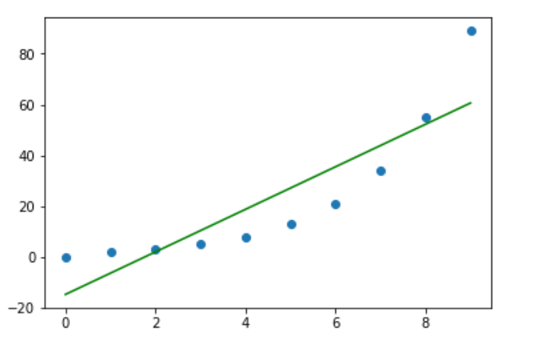

Step 2: Horizontal Y.mean() Line

Next, we will place another line on our data. If we theoretically only had Y data (and no X), the best predictive model we would be able to make would be to guess the average of Y every time. This is a key step in calculating our r-squared, as you will see in a minute.

line2 = np.full(10,[y.mean()])
plt.scatter(x,y)
plt.plot(x,line2, c = 'r')
plt.show()

Contrasted to the green regression line from earlier, this red line is much farther away from the dots. This means it has higher variance.
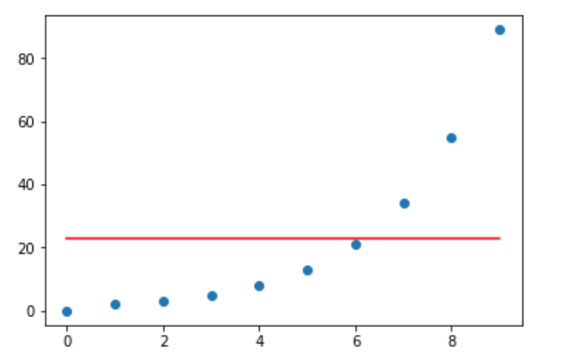

Step 3: Squared differences between the actual data points and linear model

If we measure the difference between each point of data and the linear regression line, square each difference and total them, we will get the variance that exists within the regression model.
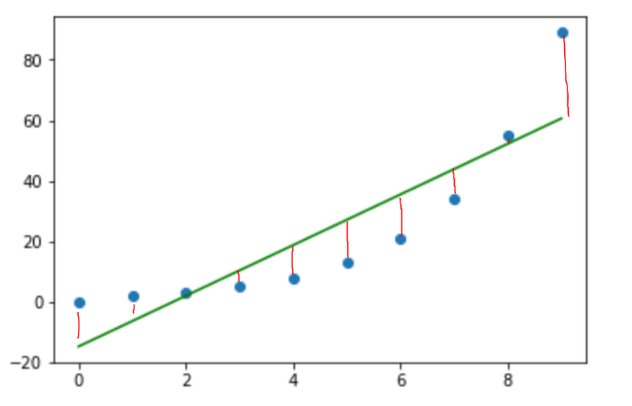
This is calculated below.
differences_line1= linefitline(x)-y
line1sum = 0
for i in differences_line1:
line1sum = line1sum + (i*i)
line1sum
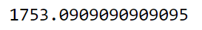

Step 4: Squared differences between the actual data points and Y.mean() line.

If we measure the difference between each point of data and the horizontal line, square each difference and total them, we will get the total variance that exists solely in the Y data set. Remember, this is the model we would use independent of our X data’s existence.
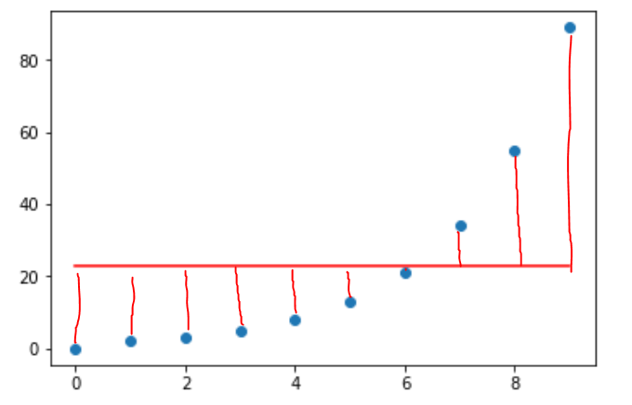
differences_line2= line2 – y
line2sum = 0
for i in differences_line2:
line2sum = line2sum + (i*i)
line2sum
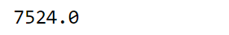

Step 5: Final step and checking work

Let’s take a step back and think about what we calculated so far:
- Variance of our linear model: 1753
- Total variance of the target variable: 7524

Let’s also remind ourselves what r-squared is defined as: “Explained variance of the model / Total variance of the target variable”.
The variance is much smaller in our regression model. This is because we took into account the information gained analyzing our X data’s relationship with our Y data. The total variance, on the other hand, had less information to begin with, thus it has a higher variance. If we want to quantify how much variance was reduced by our using our linear regression, we would take the difference between total variance and the variance of our regression line. This will give us the variance “explained by the model”. 7524–1753 = 5771

All we have to do now is put the variance explained by the model over the total variance to find rsquared: 5771/ 7524 = 0.767. This number can be interpreted as: 76.7% of the change in Y can be explained by the change in X.
Just to make sure we did it correctly, let’s check our answer with the sklearn “r2_score” function:

r2 = r2_score(y, linefitline(x))
print('The rsquared value is: ' + str(r2))

